DOCUMENT TYPE | External document
PLACE | University of Belgrade | Belgrade | SERBIA

Financial Management, Accounting & Controlling curricula development for capacity building of public administration
VISIT TO THE UNIVERISTA DEGLI STUDI GUGLIELMO MARCONI

Second study visit to the Universita degli Studi Guglielmo Marconi

Universita degli Studi Guglielmo Marconi has organized as a host second study visit from 26th to 30th in Rome, Italy. Project coordinator, Sladjana Benković, opened the meeting with a welcome speech addressing all the participants. After that Arturo Lavalle, Head of the H&R Department, on behalf of partner institution - Universita degli Studi Guglielmo Marconi, welcomed all participants and wished them successful and fruitful work during the second Study visit. Vice vector of the Universita degli Studi Guglielmo Marconi, professor Giovanni Briganti, greeted the participants and expressed gratitude for hospitality on behalf of project coordinator institution.
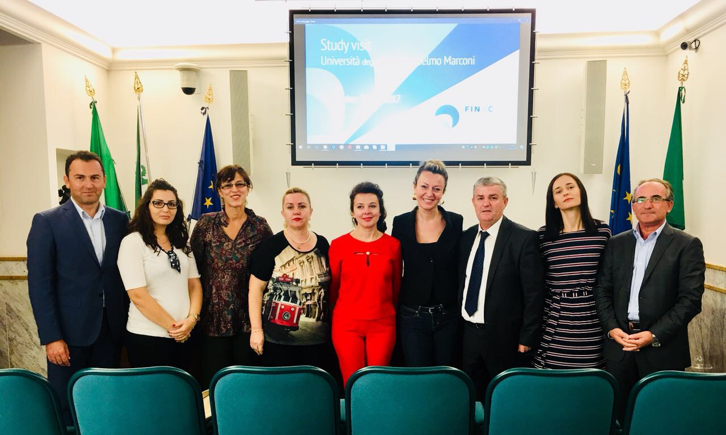
Head of the H&R Department, Arturo Lavalle, presented the results which have been obtained in the previous period and pointed out that there are numerous opportunities for cooperation within regional projects, such as FINAC. During the study visit in Italy, the representatives of partner institutions had a great opportunity to enjoy the lecture of professor Paolo Francescone who is responsible for Multimedia Educational and Creative Production Department at Universita degli Studi Guglielmo Marconi. Presentation "Distance learning methodologies and production of multimedia learning paths" was very useful for future university development. Moreover, professor Michele Petrocelli from School of Business was talking about the use of multimedia lessons and simulations in his school, giving great, vividly described examples.
Dean of School of Business at Universita degli Studi Guglielmo Marconi, professor Rainer Masera, opened the second day meeting with a welcome speech addressing all the participants. During the second day, participants had a great opportunity to hear about recent Italian budget reform and spending reviews from Mrs. Aliene Penisi, Senion Manager in the State General Accounting Department. During the presentation Francesco Tufarelli, Senior Manager at Italian Presidency of the Council of Ministries, Secretary General Automobile Club Italy, discussed the management reform in Italian Public Administration pointing out the practical application to Ministries and Public Authorities. Professor Michele Petrocelli from School of Business, who has great international experience in the public sector, discussed budgeting modernization and ethics in public sector.
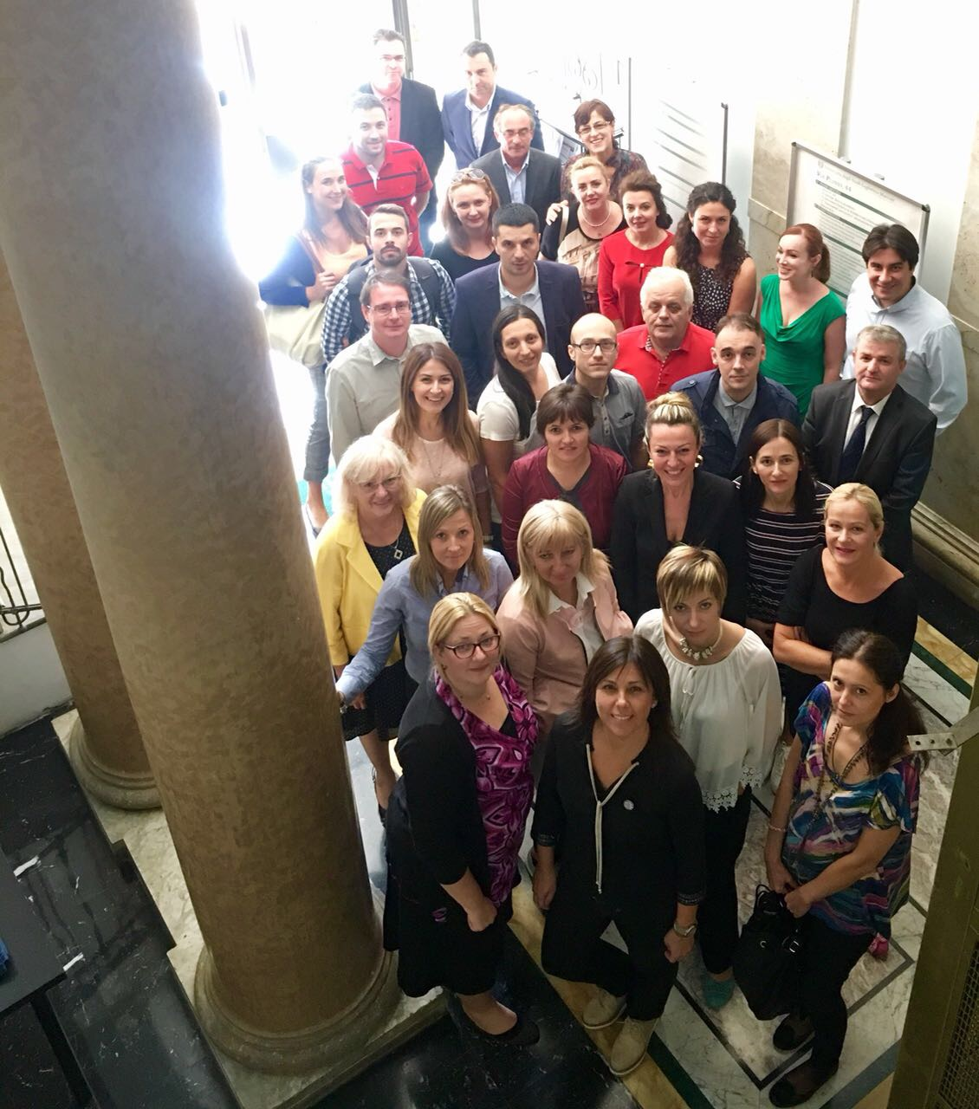
The third day of the Study visit meeting started with presentations conducted by Mrs. Zaklina Veselinović and Mr. Dejan Stanković. Professor Hysen Muceku, associate professor Arlinda Ymeraj and Blerjana Bino discussed financial management knowledge and qualifications structure of employees in Albania. After these two presentations, the study visit was concluded with future steps in next three months. At the end of the second Study visit at Universita degli Studi Guglielmo Marconi, all partners have expressed great satisfaction with organization and content of the second study visit. Best regards to the host institution.

